Assignment 1

Name: Muhammad Awais Saleem

Registration number: 400447

Discipline: Robotics and Intelligent Machine Engineering

# Task 1: Maze

## Map and instructions

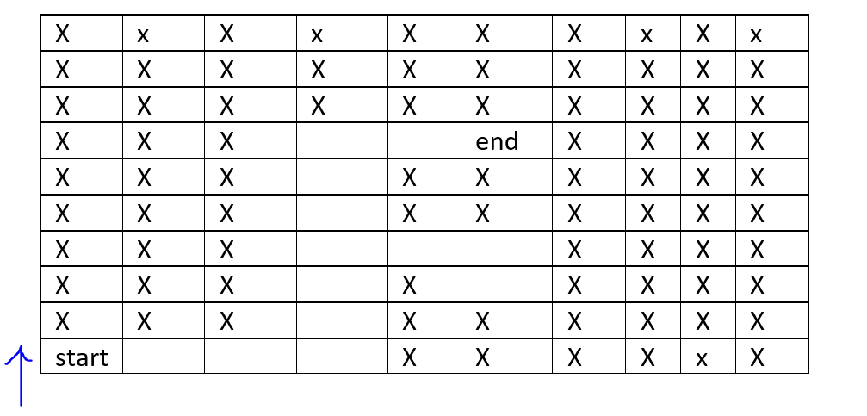

Blue arrow shows the face of the robot. The “X” in the figure 1 shows the blockage. The robot cannot move to “x” marks while the empty cells show the available path for robot. “Start” is the starting position of the robot while “end” is the final goal of the robot. One user’s command can move the robot from one cell to another.

Robot can take following commands only:

For moving forward: “forward” or “Forward”

For moving right: “right” or “Right”

For moving left: “left” or “Left”

For moving back: “back” or “Back”

## Code:

correct_path="rrrffffffrr"

robot_path=""

n=1

while(True):

print("Current robot path is: ",robot_path)

direction = input("Enter the direction: ")

if((direction=="right") or (direction=="Right")):

n=n+1

if (robot_path=="") or (robot_path=="r") or (robot_path=="rr") or (robot_path=="rrrfff") or (robot_path=="rrrffffff") or (robot_path=="rrrffffffr") or (robot_path=="rrrfffr"):

robot_path=robot_path[0:len(robot_path)] + "r"

else:

print("there is a wall at right side.")

elif ((direction=="forward") or (direction=="Forward")):

if (robot_path=="rrr") or (robot_path=="rrrf") or (robot_path=="rrrff") or (robot_path=="rrrfff") or (robot_path=="rrrffff") or (robot_path=="rrrfffff") or (robot_path=="rrrfffff") or (robot_path=="rrrfffrrb"):

robot_path=robot_path[0:len(robot_path)]+"f"

else:

print("wall infront of you! you cannot go there")

elif ((direction=="left") or (direction=="Left")):

if (robot_path=="r") or (robot_path=="rr") or (robot_path=="rrr") or (robot_path=="rrrffffffr") or (robot_path=="rrrfffr") or (robot_path=="rrrfffrr"):

robot_path=robot_path[0:len(robot_path)]+"l"

else:

print("there is a wall at you left. you cannot move left.")

elif((direction=="back") or (direction=="Back")):

if (robot_path=="rrrf") or (robot_path=="rrrff") or (robot_path=="rrrfff") or (robot_path=="rrrffff") or (robot_path=="rrrfffff") or (robot_path=="rrrffffff") or (robot_path=="rrrfffrr"):

robot_path=robot_path[0:len(robot_path)]+"b"

else:

print("there is a wall at your back. you cannot move back")

if (n!=1):

if (robot_path[-1]=="l") and (robot_path[-2]=="r"):

robot_path=robot_path[0:-2]

elif (robot_path[-1]=="b") and (robot_path[-2]=="f"):

robot_path=robot_path[0:-2]

elif (robot_path[-1]=="f") and (robot_path[-2]=="b"):

robot_path=robot_path[0:-2]

if (robot_path == correct_path):

#print("you solved the maze.")

break

# Task 2: swap two numbers

a=float(input("Enter the value of first number: "))

b=float(input("Enter the value of second number: "))

print("Before swapping: a=",a," and b=",b)

temp=a

a=b

b=a

print("After swapping: a=",a,"b=",b)

# Task 3: Calculator

while(True):

num1 = float(input("Enter the first number: "))

num2 = float(input("Enter the second number: "))

operation = input("Enter the desired operation: ")

if operation == "+":

result = num1 + num2

elif operation == "-":

result = num1 - num2

elif operation == "*":

result = num1 * num2

elif operation == "/":

result = num1 / num2

print("Output is: ",result)

print(quit)

quit=input("press Q to quit or if you wish to continue press any other key ")

if (quit=="q") or (quit=="Q"):

break

# Task 4: Fibonacci series

number1 = 0

number2 = 1

n=int(input("Enter the number of required iterations for the Fibonacci series:"))

for i in range(n):

print(number1)

mysum = number1 + number2

number1 = number2

number2 = mysum

# Task 5: length of string, substring, and concatenation

s="hello my name is awais saleem"

#length of string

print("The length of string is: ", len(s))

#sub string

sub_s1=s[17:]

print("The substring is: ",sub_s1)

#concatination of strings

greetings=s[0:17]

# print(greetings)

fname="talha"

lname="ahmed"

concat_str=greetings+fname+" "+lname

print(concat_str)

# Task 6: Factorial

#factorial using recursion

# numb=int(input("Enter the number: "))

# fact=1

# def factorial(numb):

# if numb==1:

# return 1

# else:

# out=numb*(factorial(numb-1))

# return out

# fact=factorial(numb)

# print("factorial of number",numb,"is", fact)

#without recursion

numb=int(input("Enter the number: "))

fact=1

if numb>0:

for i in range(1,numb+1):

fact=fact*i

elif numb==0:

fact=1

else:

print("enter the positive whole number")

if numb>0:

print("factorial of number",numb,"is", fact)